MARCH 2019 SPACE ECONOMY NEWS -JAD

https://spacenews.com/

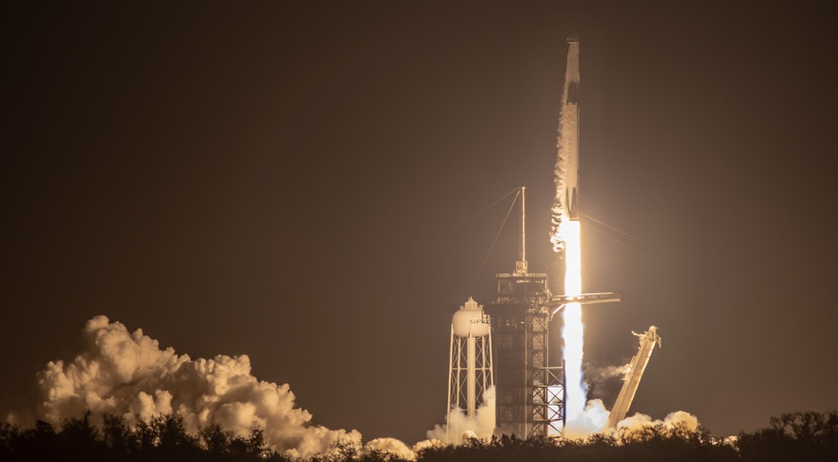
CIVIL COMMERCIAL

Falcon 9 launches Crew Dragon on key test flight
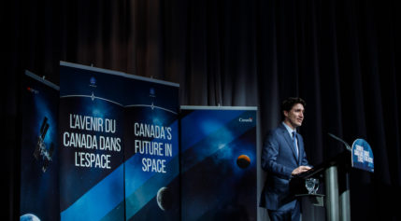
CIVIL

Canada becomes first nation to formally commit to NASA’s lunar Gateway
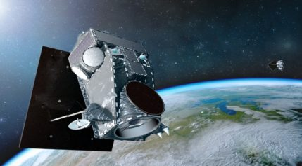
COMMERCIAL

Maxar to retain but restructure GEO satellite business
- 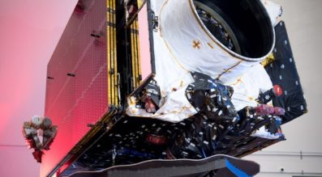
COMMERCIAL

Maxar cutting jobs to help stem $1.2 billion loss, stabilize satellite division
Maxar Technologies, which will lay off more than 200 people as it seeks to return to profitability, says the struggling satellite division it decided to keep will need to bring in roughly $500 million this year to break even.
- 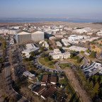
FROM THE MAGAZINE

Foust Forward | The government shutdown’s shadow on commercial space
- 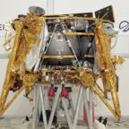
COMMERCIAL

SpaceIL back on course for the moon after computer glitch
- 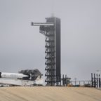
CIVIL COMMERCIAL

More work ahead for Crew Dragon after test flight

- 
MILITARY POLICY & POLITICS

Space Force proposal officially sent to Capitol Hill, now come the questions
- 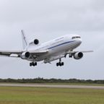
CIVIL LAUNCH

Pegasus woes continue to delay NASA mission
- 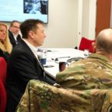
COMMERCIAL MILITARY

Air Force laying groundwork for future military use of commercial megaconstellations
- 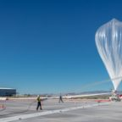
COMMERCIAL

World View hires new CEO
- 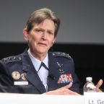
SN MILITARY.SPACE

Is the Space Development Agency a threat to SMC?
- 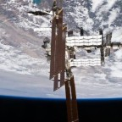
CIVIL POLICY & POLITICS

Senate bill seeks extension of the space station
- 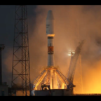
COMMERCIAL LAUNCH

OneWeb’s first six satellites in orbit following Soyuz launch
- 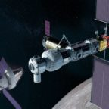
CIVIL

Shutdown to delay first element of NASA’s lunar Gateway
- 
COMMERCIAL

Iceye expands staff to prepare for constellation
- 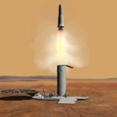
CIVIL

NASA unlikely to return Mars samples in the 2020s
- 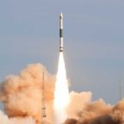
LAUNCH

Chinese state-owned firms preparing to launch new commercial rockets
- 

Op-ed | Sustainability on Earth depends on our exploration of space

NASA

Latest NASA News Releases

Results (1667)

NASA, SpaceX Launch First Flight Test of Space System Planned for Crew
March 2, 2019 - For the first time in history, a commercially-built and operated American crew spacecraft and rocket, which launched from American soil, is on its way to the International Space Station.

NASA Secures First International Partnership for Lunar Gateway
Feb. 28, 2019 - The following is a statement from NASA Administrator Jim Bridenstine on the announcement Thursday by Canadian Prime Minister Justin Trudeau about Canada’s support for the Gateway lunar outpost and deep space exploration:

NASA Awards Contract for Construction Services
Feb. 28, 2019 - NASA has awarded a contract to 13 U.S. companies for building construction services at several California facilities.

NASA Awards Contract for Protective Services at Houston Facilities
Feb. 28, 2019 - NASA has awarded a contract to Praetorian Standard Inc., of Fayetteville, North Carolina, a service disabled veteran-owned small business, to provide comprehensive security services at the agency’s Johnson Space Center in Houston, as well as facilities managed by Johnson.

NASA Selects Mission to Study Space Weather from Space Station
Feb. 26, 2019 - NASA has selected a new mission that will help scientists understand and, ultimately, forecast the vast space weather system around our planet.

New ‘NASA Science Live’ Program Premieres This Week
Feb. 25, 2019 - NASA invites you to take a behind-the-scenes look at how the agency explores Earth and outer space with a new monthly television series that premieres this week.

NASA Awards Support Services Contract for Exploration Ground Systems
Feb. 22, 2019 - NASA has selected LJT & Associates, Incorporated of Columbia, Maryland, to provide support services to the Exploration Ground Systems (EGS) Program at the agency’s Kennedy Space Center in Florida.

NASA Renames Facility in Honor of ‘Hidden Figure’ Katherine Johnson
Feb. 22, 2019 - NASA has redesignated its Independent Verification and Validation (IV&V) Facility in Fairmont, West Virginia, as the Katherine Johnson Independent Verification and Validation Facility, in honor of the West Virginia native and NASA "hidden figure."

NASA Administrator Statement on Israeli Moon Mission
Feb. 22, 2019 - The following is a statement from NASA Administrator Jim Bridenstine on Thursday’s launch of Israel’s first mission beyond Earth’s orbit. SpaceIL’s lander blasted off from Cape Canaveral Air Force Station in Florida, and now is on its way to becoming the first commercial lander to reach the Moon’s surface.

NASA Selects Experiments for Possible Lunar Flights in 2019
Feb. 21, 2019 - NASA has selected 12 science and technology demonstration payloads to fly to the Moon as early as the end of this year, dependent upon the availability of commercial landers.

NASA-Funded Research Creates DNA-like Molecule
Feb. 21, 2019 - In a research breakthrough funded by NASA, scientists have synthesized a molecular system that, like DNA, can store and transmit information. This unprecedented feat suggests there could be an alternative to DNA-based life, as we know it on Earth – a genetic system for life that may be possible on other worlds.

NASA to Provide Coverage of SpaceX Commercial Crew Flight Test
Feb. 20, 2019 - NASA will provide coverage of the upcoming prelaunch and launch activities for the SpaceX Demo-1 flight test to the International Space Station for the agency’s Commercial Crew Program, which is working with the U.S. aerospace industry to launch astronauts on American rockets and spacecraft from American soil for the first time since 2011.

New NASA Book Shares Beauty of Earth from Space
Feb. 20, 2019 - Swirling white clouds, deep blue oceans and multicolored landscapes bring to life the pages of NASA’s new 168-page book “Earth,” a collection of dramatic images captured by Earth-observing satellites. The book is available now in hardcover and ebook, and online with interactive features.

NASA Tests Urban Drone Traffic Management in Nevada, Texas
Feb. 19, 2019 - NASA has selected two organizations to host the final phase of its four-year series of increasingly complicated technical demonstrations involving small Unmanned Aircraft Systems (UAS), commonly known as drones.

Florida Students to Speak with NASA Astronaut Aboard Space Station
Feb. 15, 2019 - University and high school students from Florida will have an opportunity to talk with a NASA astronaut on the International Space Station next week.

NASA Selects New Mission to Explore Origins of Universe
Feb. 13, 2019 - NASA has selected a new space mission that will help astronomers understand both how our universe evolved and how common are the ingredients for life in our galaxy’s planetary systems.

NASA's Record-Setting Opportunity Rover Mission on Mars Comes to End
Feb. 13, 2019 - One of the most successful and enduring feats of interplanetary exploration, NASA's Opportunity rover mission is at an end after almost 15 years exploring the surface of Mars and helping lay the groundwork for NASA’s return to the Red Planet.

NASA Astronauts Available for Interviews Before Space Station Mission
Feb. 13, 2019 - NASA astronauts Nick Hague and Christina Koch will be available for live satellite interviews Friday, Feb. 22, as they undergo final training before their launch to the International Space Station, scheduled for March 14.

NASA to Share Results of Effort to Recover Mars Opportunity Rover
Feb. 12, 2019 - NASA will discuss the status of its Mars Exploration Rover (MER) Opportunity in a media briefing at 2 p.m. EST (11 a.m. PST) Wednesday, Feb. 13, from the agency’s Jet Propulsion Laboratory (JPL) in Pasadena, California. The briefing will air live on NASA Television, the agency's website and YouTube.

Media Invited to Talk Tech with NASA Administrator at World Ag Expo
Feb. 9, 2019 - NASA Administrator Jim Bridenstine will speak to, and take questions from, media about how technologies originally developed for space exploration now are used to cultivate farms, predict crop yields, manage water resources, and more, during his Tuesday, Feb. 12, visit to World Ag Expo in Tulare, California.

Results (1667)

NASA, SpaceX Launch First Flight Test of Space System Planned for Crew
March 2, 2019 - For the first time in history, a commercially-built and operated American crew spacecraft and rocket, which launched from American soil, is on its way to the International Space Station.

NASA Secures First International Partnership for Lunar Gateway
Feb. 28, 2019 - The following is a statement from NASA Administrator Jim Bridenstine on the announcement Thursday by Canadian Prime Minister Justin Trudeau about Canada’s support for the Gateway lunar outpost and deep space exploration:

NASA Awards Contract for Construction Services
Feb. 28, 2019 - NASA has awarded a contract to 13 U.S. companies for building construction services at several California facilities.

NASA Awards Contract for Protective Services at Houston Facilities
Feb. 28, 2019 - NASA has awarded a contract to Praetorian Standard Inc., of Fayetteville, North Carolina, a service disabled veteran-owned small business, to provide comprehensive security services at the agency’s Johnson Space Center in Houston, as well as facilities managed by Johnson.

NASA Selects Mission to Study Space Weather from Space Station
Feb. 26, 2019 - NASA has selected a new mission that will help scientists understand and, ultimately, forecast the vast space weather system around our planet.

New ‘NASA Science Live’ Program Premieres This Week
Feb. 25, 2019 - NASA invites you to take a behind-the-scenes look at how the agency explores Earth and outer space with a new monthly television series that premieres this week.

NASA Awards Support Services Contract for Exploration Ground Systems
Feb. 22, 2019 - NASA has selected LJT & Associates, Incorporated of Columbia, Maryland, to provide support services to the Exploration Ground Systems (EGS) Program at the agency’s Kennedy Space Center in Florida.

NASA Renames Facility in Honor of ‘Hidden Figure’ Katherine Johnson
Feb. 22, 2019 - NASA has redesignated its Independent Verification and Validation (IV&V) Facility in Fairmont, West Virginia, as the Katherine Johnson Independent Verification and Validation Facility, in honor of the West Virginia native and NASA "hidden figure."

NASA Administrator Statement on Israeli Moon Mission
Feb. 22, 2019 - The following is a statement from NASA Administrator Jim Bridenstine on Thursday’s launch of Israel’s first mission beyond Earth’s orbit. SpaceIL’s lander blasted off from Cape Canaveral Air Force Station in Florida, and now is on its way to becoming the first commercial lander to reach the Moon’s surface.

NASA Selects Experiments for Possible Lunar Flights in 2019
Feb. 21, 2019 - NASA has selected 12 science and technology demonstration payloads to fly to the Moon as early as the end of this year, dependent upon the availability of commercial landers.

NASA-Funded Research Creates DNA-like Molecule
Feb. 21, 2019 - In a research breakthrough funded by NASA, scientists have synthesized a molecular system that, like DNA, can store and transmit information. This unprecedented feat suggests there could be an alternative to DNA-based life, as we know it on Earth – a genetic system for life that may be possible on other worlds.

NASA to Provide Coverage of SpaceX Commercial Crew Flight Test
Feb. 20, 2019 - NASA will provide coverage of the upcoming prelaunch and launch activities for the SpaceX Demo-1 flight test to the International Space Station for the agency’s Commercial Crew Program, which is working with the U.S. aerospace industry to launch astronauts on American rockets and spacecraft from American soil for the first time since 2011.

New NASA Book Shares Beauty of Earth from Space
Feb. 20, 2019 - Swirling white clouds, deep blue oceans and multicolored landscapes bring to life the pages of NASA’s new 168-page book “Earth,” a collection of dramatic images captured by Earth-observing satellites. The book is available now in hardcover and ebook, and online with interactive features.

NASA Tests Urban Drone Traffic Management in Nevada, Texas
Feb. 19, 2019 - NASA has selected two organizations to host the final phase of its four-year series of increasingly complicated technical demonstrations involving small Unmanned Aircraft Systems (UAS), commonly known as drones.

Florida Students to Speak with NASA Astronaut Aboard Space Station
Feb. 15, 2019 - University and high school students from Florida will have an opportunity to talk with a NASA astronaut on the International Space Station next week.

NASA Selects New Mission to Explore Origins of Universe
Feb. 13, 2019 - NASA has selected a new space mission that will help astronomers understand both how our universe evolved and how common are the ingredients for life in our galaxy’s planetary systems.

NASA's Record-Setting Opportunity Rover Mission on Mars Comes to End
Feb. 13, 2019 - One of the most successful and enduring feats of interplanetary exploration, NASA's Opportunity rover mission is at an end after almost 15 years exploring the surface of Mars and helping lay the groundwork for NASA’s return to the Red Planet.

NASA Astronauts Available for Interviews Before Space Station Mission
Feb. 13, 2019 - NASA astronauts Nick Hague and Christina Koch will be available for live satellite interviews Friday, Feb. 22, as they undergo final training before their launch to the International Space Station, scheduled for March 14.

NASA to Share Results of Effort to Recover Mars Opportunity Rover
Feb. 12, 2019 - NASA will discuss the status of its Mars Exploration Rover (MER) Opportunity in a media briefing at 2 p.m. EST (11 a.m. PST) Wednesday, Feb. 13, from the agency’s Jet Propulsion Laboratory (JPL) in Pasadena, California. The briefing will air live on NASA Television, the agency's website and YouTube.

Media Invited to Talk Tech with NASA Administrator at World Ag Expo
Feb. 9, 2019 - NASA Administrator Jim Bridenstine will speak to, and take questions from, media about how technologies originally developed for space exploration now are used to cultivate farms, predict crop yields, manage water resources, and more, during his Tuesday, Feb. 12, visit to World Ag Expo in Tulare, California.

SPACE X

FEBRUARY 23, 2019

NUSANTARA SATU MISSION
On Thursday, February 21 at 8:45 p.m. EST, SpaceX launched the Nusantara Satu satellite from Space Launch Complex 40 (SLC-40) at Cape Canaveral Air Force Station, Florida.
READ ARTICLE
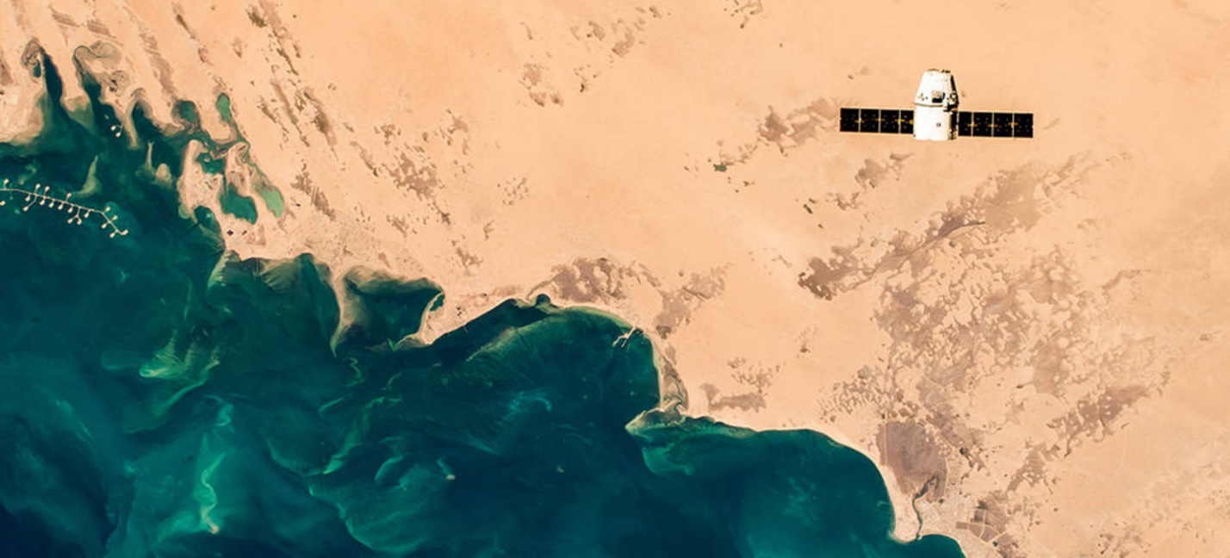
JANUARY 14, 2019

DRAGON RESUPPLY MISSION (CRS-16)
Packed with about two tons of cargo and science, SpaceX’s Dragon spacecraft departed the International Space Station on Sunday, January 13. A parachute-assisted splashdown in the Pacific Ocean occurred at about 9:10 p.m.
READ ARTICLE
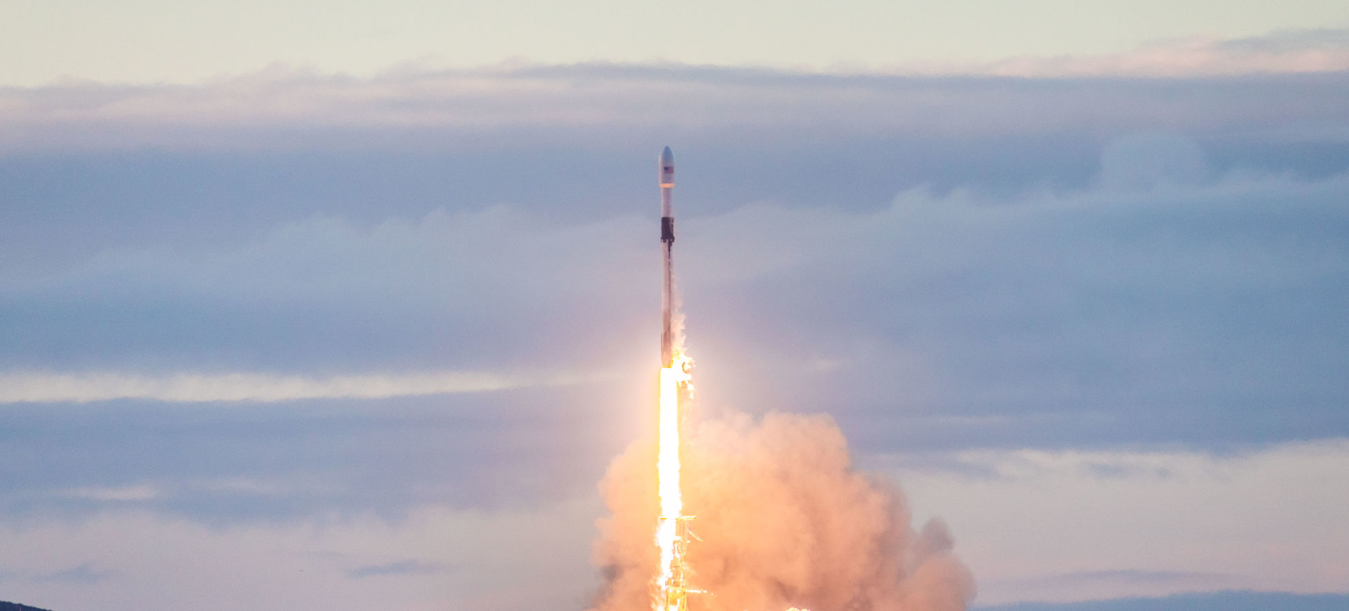
JANUARY 11, 2019

IRIDIUM-8 MISSION
On Friday, January 11 at 7:31 a.m. PST, 15:31 UTC, SpaceX successfully launched the eighth and final set of satellites in a series of 75 total satellites for Iridium’s next generation global satellite constellation, Iridium NEXT.
READ ARTICLE
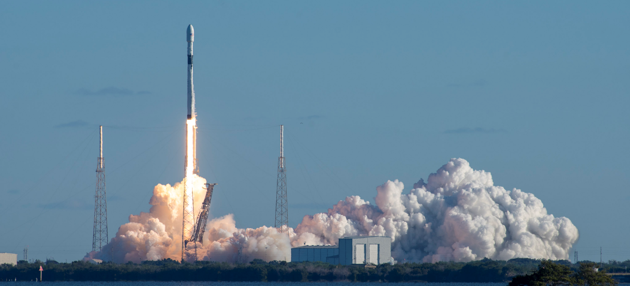
DECEMBER 23, 2018

GPS III SPACE VEHICLE 01 MISSION
On Sunday, December 23rd at 5:51 a.m. PST, SpaceX successfully launched the United States Air Force’s first Global Positioning System III space vehicle (SV) from Space Launch Complex 40 (SLC-40) at Cape Canaveral Air Force Station, Florida.
READ ARTICLE
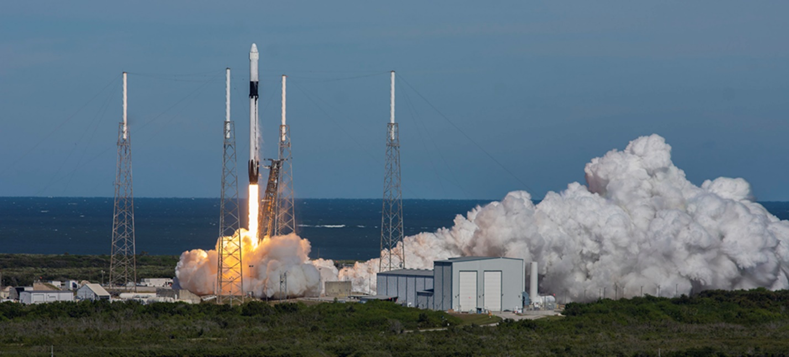
DECEMBER 05, 2018

DRAGON RESUPPLY MISSION (CRS-16)
On Wednesday, December 5, 2018, SpaceX launched its sixteenth Commercial Resupply Services mission (CRS-16) to the International Space Station. Liftoff occurred at 1:16 p.m.
READ ARTICLE
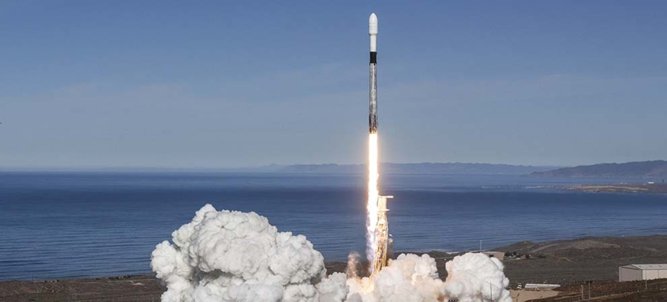
DECEMBER 03, 2018

SPACEFLIGHT SSO-A: SMALLSAT EXPRESS MISSION
On Monday, December 3rd at 10:34 a.m. PST, SpaceX successfully launched Spaceflight SSO-A: SmallSat Express to a low Earth orbit from Space Launch Complex 4E (SLC-4E) at Vandenberg Air Force Base, California.
READ ARTICLE
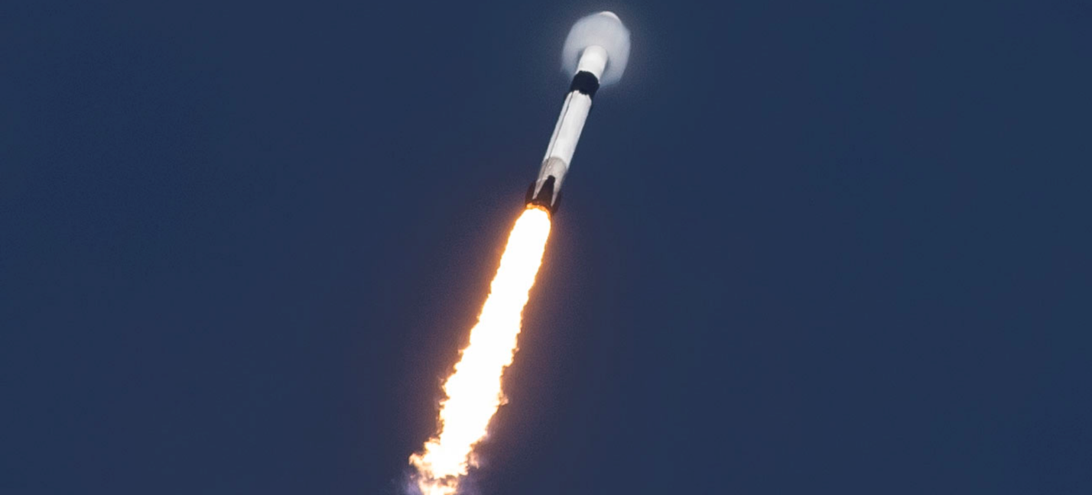
NOVEMBER 15, 2018

ES'HAIL-2 MISSION
SpaceX successfully launched the Es’hail-2 satellite on Thursday, November 15 from Launch Complex 39A (LC-39A) at NASA’s Kennedy Space Center in Florida. Liftoff occurred at 3:46 p.m.
READ ARTICLE
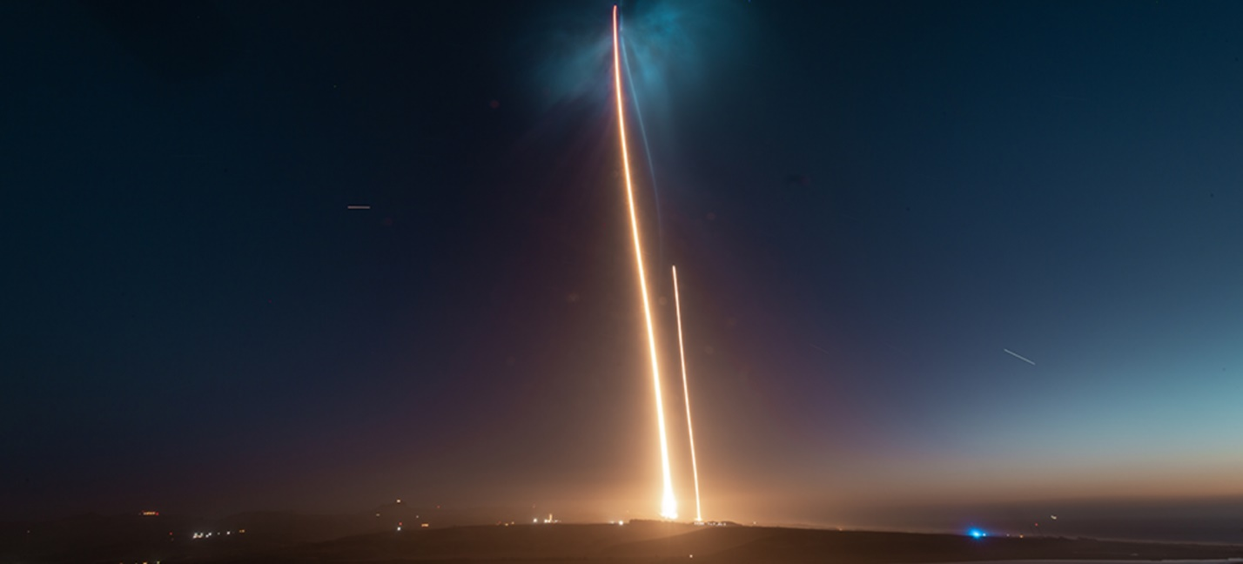
OCTOBER 07, 2018

SAOCOM 1A MISSION
On Sunday, October 7 at 7:21 p.m. PDT, SpaceX successfully launched the SAOCOM 1A satellite from Space Launch Complex 4E (SLC-4E) at Vandenberg Air Force Base in California. The satellite was deployed about 12 minutes after liftoff.
READ ARTICLE
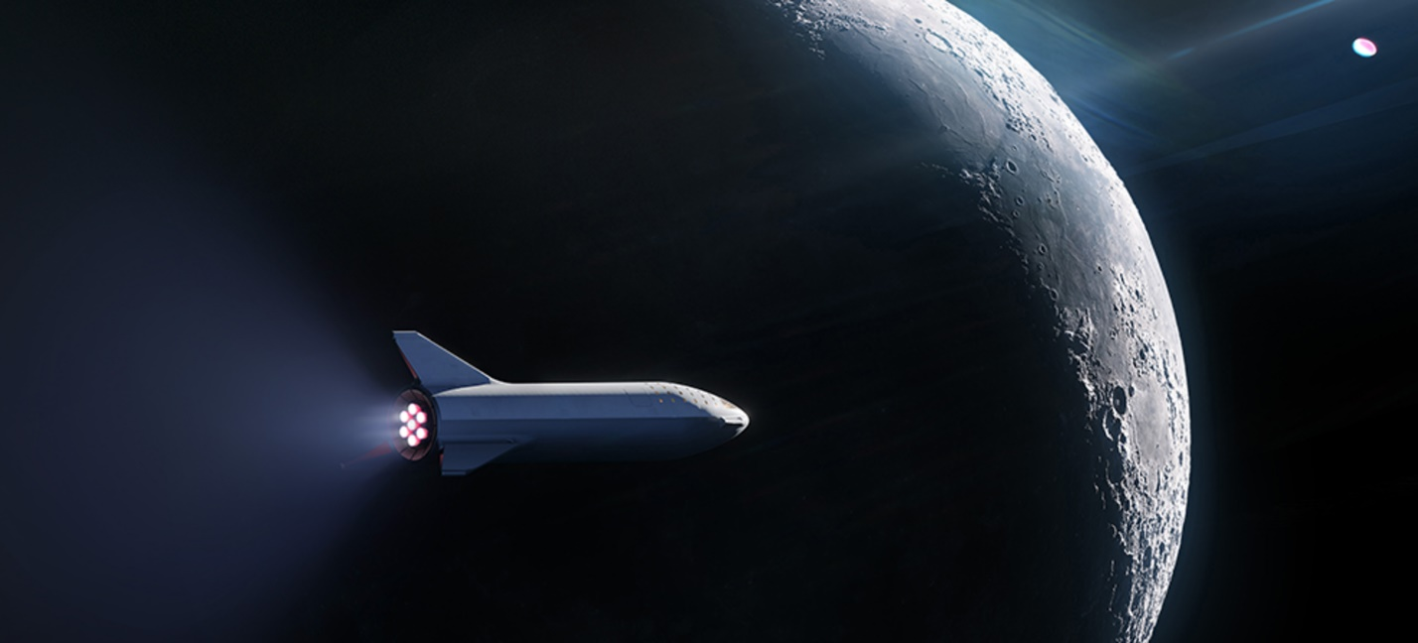
SEPTEMBER 18, 2018

FIRST PASSENGER ON LUNAR BFR MISSION
On September 17, 2018, SpaceX announced fashion innovator and globally recognized art curator Yusaku Maezawa will be the company’s first private passenger to fly around the Moon in 2023.
READ ARTICLE
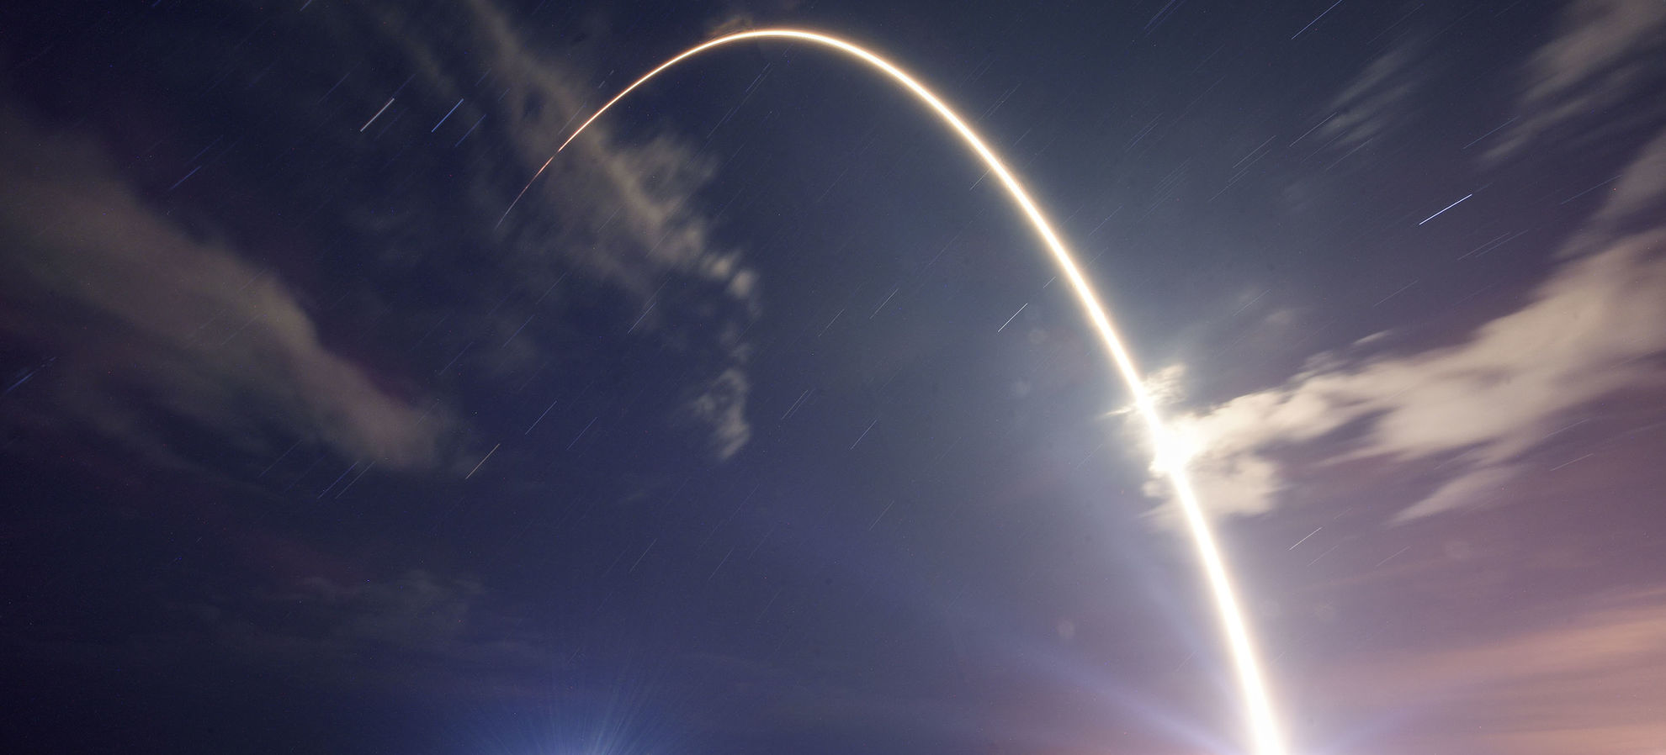
SEPTEMBER 09, 2018

TELSTAR 18 VANTAGE MISSION
On Monday, September 10th, SpaceX's Falcon 9 successfully lifted off at 12:45 a.m.
READ ARTICLE
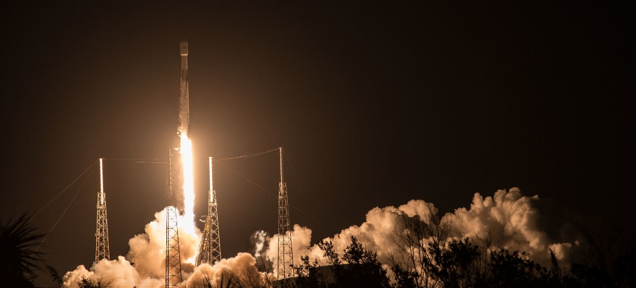
AUGUST 06, 2018

MERAH PUTIH MISSION
On Tuesday, August 7th at 1:18 a.m. EDT, Falcon 9 successfully lifted off from Space Launch Complex 40 (SLC-40) at Cape Canaveral Air Force Station, Florida carrying the Merah Putih mission for PT Telkom Indonesia.
READ ARTICLE
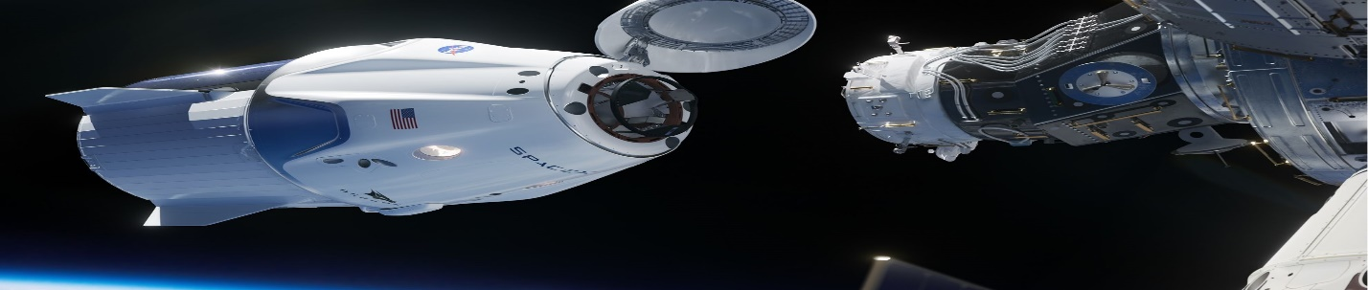
AUGUST 04, 2018

NASA ASTRONAUTS FLYING ABOARD CREW DRAGON
On Friday, August 3, 2018, NASA announced the first four astronauts who will launch aboard Crew Dragon (also known as Dragon 2) to the International Space Station as part of NASA’s Commercial Crew P
READ ARTICLE

ESA

https://www.esa.int/Our_Activities/Space_News

ESA > Our Activities > Space News

OUR MISSIONS
All missions
NAME | LAUNCH | MISSION
EDRS | 2016 | Geostationary satellites for relaying satellite data

Exomars | 2016 | Mars orbiter and lander, followed by rover and surface platform
SmallGEO | 2017 | New small platform for geostationary telecommunications

LATEST NEWS

Space weather kicks up a social storm01 March 2019
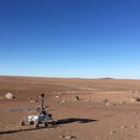
Fit for Mars28 February 2019
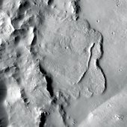
First evidence of planet-wide groundwater system on Mars28 February 2019
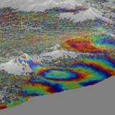
Copernicus Sentinel-1 reveals shared plumbing led to Agung awakening22 February 2019

Signs of ancient flowing water on Mars21 February 2019
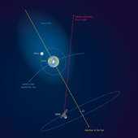
Earth’s atmosphere stretches out to the Moon – and beyond20 February 2019
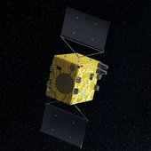
Close encounters: planning for extra Hera flyby20 February 2019
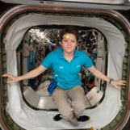
Space behaviour19 February 2019
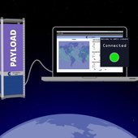
Interactive space simulation for nanosatellites19 February 2019
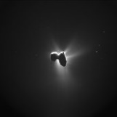
Rosetta’s comet sculpted by stress18 February 2019

Astronaut photography benefiting the planet15 February 2019
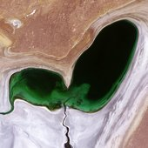
Shrinking heart13 February 2019
Shrinking heart13 February 2019 This heart-shaped body of water may look cute for Valentine’s Day but just as love sometimes fades, this emerald sea is withering away.

ROSCOSMOS

- March 02, 2019Roscosmos and NASA Work Out the Safety Protocols for Docking of American Spacecraft
- February 19, 2019Roscosmos and Space Adventures signed a contract for the implementation of the short duration space flights to the ISS
- February 13, 2019GK Activated Online Launch Price Calculator for SmallSats

CHINA SPACE AGENCY

http://www.cnsa.gov.cn/english/index.html

Xi meets Chang'e-4 mission representatives | 02-21

China's Chang'e-4 probe wakes up after first lunar night | 02-01

China open to int'l cooperation in future space missions | 01-15

China declares Chang'e-4 mission complete success | 01-15

China welcomes world's scientists to collaborate in lunar explorat... | 01-15

Chang'e-4 probe takes panoramic photos on moon's far side | 01-15

Breathtaking 12 minutes for Chang'e-4's landing | 01-04

China names new moon rover "YuTu-2" | 01-04

Chang'e-4 lands on largest crater in solar system | 01-04

China's Chang'e-4 probe makes historic landing on moon's far side | 01-03

1 2 3 4 5 6 7 8 9 10 下页 尾页 总页数:36

VIRGIN GALACTIC

Virgin Galactic Makes Space for Second Time in Ten Weeks with Three On Board, Reaching Higher Altitudes and Faster Speeds, as Flight Test Program Continues
Read more

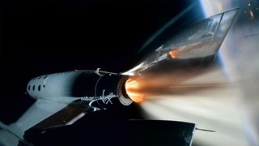

SpaceShipTwo, VSS Unity, Prepares For Fifth Supersonic Powered Test Flight
Read more

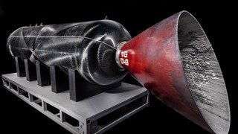

Spaceflight Rocket Motor donated to the Smithsonian Air & Space Museum
Read more

Virgin Galactic Pilots Awarded Commercial Astronaut Wings
Read more

Virgin Galactic Unveils Under Armour As Exclusive Technical Spacewear Partner
Read more

FEBRUARY 7, 2019

Spaceflight Rocket Motor donated to the Smithsonian Air & Space Museum
Read more

JANUARY 24, 2019

Virgin Galactic Unveils Under Armour As Exclusive Technical Spacewear Partner
Read more

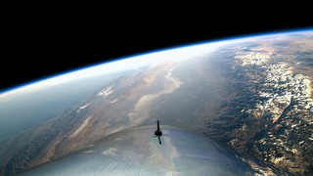

DECEMBER 13, 2018

Richard Branson Welcomes Astronauts Home from Virgin Galactic’s Historic First Spaceflight
Read more

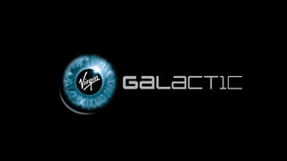

DECEMBER 12, 2018

Virgin Galactic Flight Test Program Update - SpaceShipTwo Preparing For Fourth Powered Test Flight
Read more

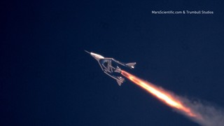

JULY 26, 2018

Into the Mesosphere at Mach 2.4
Read more

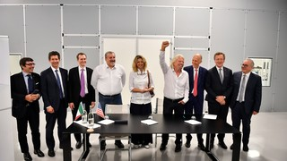

JULY 6, 2018

ALTEC, SITAEL, Virgin Galactic & The Spaceship Company Sign Framework to Bring Commercial Spaceflights to Italy
Press Release
Read more

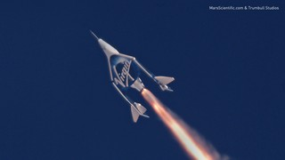

MAY 29, 2018

Richard Branson Welcomes VSS Unity Home from Second Supersonic Flight
Read more

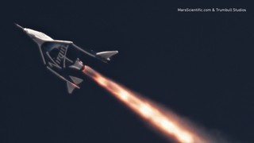

APRIL 5, 2018

VSS Unity First Powered Flight
A major step forward
Read more

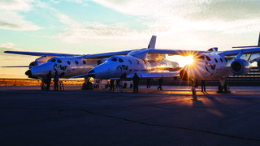

JANUARY 11, 2018

Update From Mojave: VSS Unity Successfully Completes High Speed Glide Flight
Unity successfully completed her seventh glide flight.
Read more

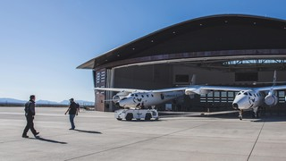

DECEMBER 18, 2017

Italian Space Agency (ASI) Signs Letter Of Intent For Virgin Galactic Research Flight
Press Release
Read more

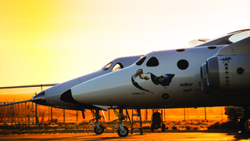

OCTOBER 26, 2017

Kingdom Of Saudi Arabia And Virgin Announce Partnership On Spaceflight, Satellite Launch And Space Centric Entertainment Industry
Press Release
Read more

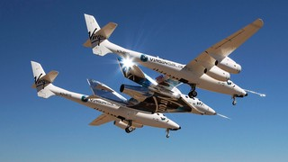

AUGUST 4, 2017

Update From Mojave: VSS Unity Flies With Propulsion Systems Installed And Live
This was Unity’s sixth glide test and essentially a dry run for rocket-powered flights.
Read more

https://www.virgingalactic.com/news/

